

**JOMO KENYATTA UNIVERSITY OF AGRICULTURE AND TECHNOLOGY KAREN CAMPUS**

**Topic**:

Online Survey Tool Management System: Case Nairobi city, Nairobi County.

Presented by: **Jaleny Francis**

Reg no: SCT 121 C002 0345/2016

Diploma Information Technology

**Supervisor**: **Mr. Michael Otieno Okumu**.

Submitted to the faculty of Information Technology in partial fulfilment of the requirements for the award of Diploma in Information Technology.

**DECEMBER 2017**

**Declaration:**

I Jaleny Francis declare that this is my project and has never been submitted to this or any other university for the award of a Diploma in Information Technology or any other award. All foreign materials have been cited in the references.

Student signature

Sign …………………………… Date………………………………….

Supervisor’s signature

Sign ………………………………. Date ………………………...

**Acknowledgement**

The completion of this undertaking could not have been possible without the participation and assistance of so many people whose names may not all be enumerated. Their contributions are sincerely appreciated and gratefully acknowledged. However, I would like to express my deep appreciation and indebtedness particularly to the following. Mr. Michael Otieno Okumu, Ms. Mary Jaleny, Mr. David Kiptoo and Mr. Donald Jaleny for their endless support, kind and understanding spirit during the creation of the project. To all the relative’s friends and others who in one way or another shared their support, either morally, financially and physically, thank you.

Above all, to the Great Almighty, the author of knowledge and wisdom for his countless love.

**Abstract**

The survey offers a new method to the high-tech surveys’ profession by exploring the market research, HealthCare, compliance, non-profit, profit management, 360 review package, product management, product feedback management and education. The survey help you build style test and share your survey examine all within a user interface it also help you share your survey on twitter, Facebook and Instagram you can even go old school to print. They survey also going to give you details on how people respondent to your survey, how many people respond from the mobile phones and desktops.

TABLE OF CONTENT

CHAPTER 1: Project Proposal 1

Introduction 1

1.2 Problem Statement 2

1.3 Proposed Solution 3

1.4 Objectives 4

1.5 Specific Objectives 4

1.6 Research Questions 4

1.7 Justification 5

1.8 Scope 5

1.9 Limitations and Assumptions 6

1.10 Conclusion 6

Chapter 2: Literature Review 7

Introduction 7

2.2 Current system 7

2.3 Gaps Existing in the Current System 7

Systems available locally 8

2.2.1.1 Clear voice surveys 8

Figure 2.0.1 clear voice survey sign up 8

Figure 2.0.2 clear voice survey incentive 9

Figure 2.0.3 clear voice survey ratings about a particular product 9

Systems available globally 10

2.2.2.1 Google Forms 10

Figure 2.2.1.1 10

2.4 Proposed System 12

2.5 conclusion 12

Chapter 3 13

3.0 Research Methodology 13

3.1 Introduction 13

3.2 System Development 13

3.2.1 Prototype model 13

Figure 3.2.1.1 15

3.2.2 Research Methodology 15

3.2.3 Data collection methods 15

3.2.3.1 Interviews 15

3.2.3.2 Observation 16

3.3 System Development Tools 17

3.3.1 Database 17

3.3.2 User Interface (UI) 17

3.3.3 Hosting 17

3.3.4 Text editor 17

3.4 Users of the System 18

3.4.1 System Administrator 18

3.4.2 Business owners 18

3.4.3 Customers 18

3.5 System Design Model 19

Figure 3.5.1: Sign up and Login process 19

4.1 Narrative 20

4.2 Use Case diagram 21

4.3 Flowchart 22

4.3.1 Flowchart 2 23

4.4 Entity Relationship Diagram 24

4.5 Class diagram 25

CHAPTER 5: SYSTEM IMPLEMENTATION AND TESTING 26

5.0 Introduction 26

5.1 system module 26

Web survey and report module 26

Interviewing CATI Module 26

Online interviewing module 26

Survey recording module 26

Online panel management module 26

5.2 Modules implementation 27

Web survey and report module 27

Online interviewing module 27

5.3 Information security 27

5.4 Conclusion 27

# CHAPTER 1: **Project Proposal**

# Introduction

**1.**1 Background Information

An online survey is a questionnaire that the target audience can complete over the Internet. Online surveys are usually created as Web forms with a database to store the answers and statistical software to provide analytics.People are often encouraged to complete online surveys by an incentive such as being entered to win a prize. Companies often use online surveys to gain a deeper understanding of their customers’ tastes and opinions. Like traditional surveys, online surveys can be used in two basic ways: To provide more data on customers, including everything from basic demographic information (age, education level and so on) to social data (causes, clubs or activities the customer supports) To create a survey about a specific product, service or brand in order to find out how consumers are reacting to it. In contrast to traditional surveys, online surveys offer companies a way to sample a broader audience at a lower cost.

Nairobi is a city located in Kenya and it is the capital city of the country. Currently Nairobi has a population of about 2 million. The city is also assumed the hub of business economy in the nation of Kenya. It is a city that is steady fast in growth of economy and one of the leading city in Kenya with many entrepreneurs’ running many activities in the central business area.

Due to the rapid growth of businesses running in the central business area in the city that actually started around the 1960s after the country attained her independence the online survey has actually never been exploited to the full potential despite the city’s improved infrastructure and technology that is greatly appreciated by the resident.

By the introduction of an online survey system, which is an automated system, this will greatly improve the services offered to the customers at low cost. The system will greatly enhance the company’s relationship and the customers. It will adversely help the customers know more about the products likewise to the company, which help, know their customers’ opinion about certain products.

# 1.2 Problem Statement

As explained in 1.1 above, there is a big problem experienced by the entrepreneurs’ when carrying out research about services they offer to their customers. Most researchers do not employ the automated method and are often left with the traditional method as the better option. The kind of survey they always contact does not provide more data on customer’s basic demographic information and customers’ social data. The current system also cannot sign up customers in their systems. There is also high insecurity of the research carried out since the findings are always not kept in safe place and this can lead to the collapse of a company since one can easily retrieve a valuable information that can sabotage the whole company at once. The system also carries sample research to a confined number of people that cannot add up to what all the customers expect or think about the organization or a particular company.

# 1.3 Proposed Solution

The researcher here aims at developing a web based platform where the organization can upload their company’s logo and kind of products they offer or would like to offer if incase it’s a startup company, the targeted respondents can view and air out their opinions and how they feel about the products offered to them. They can also suggest or voice out how they want the company to improve its product formulation to the market

Study wants to make it easy for the organization or a particular entrepreneur to easily get to know what the customers feel about a particular service they offer or a particular product.

It will also enable the customers to easily access the details of the available products without physical going to the shop to check whether there is a particular product.

# 1.4 Objectives

1. To develop a system that can analyze records store them and retrieve them when need.
2. To develop a standard alone system that that will automate the process of survey.
3. To develop a system that will sign in users

# 1.5 Specific Objectives

1. To establish a system that will enable a user automate the survey process.
2. To develop a system that enables the user carry out 360-review package.
3. To develop a system that will allow users to contact any kind of survey allow users key in words

# 1.6 Research Questions

1. What are the current survey systems?
2. What are the challenges faced by the current surveys?
3. What are the systems used for survey?

# 1.7 Justification

This study will eventually solve the stalemate that has always been in the process of carrying out survey. By developing a new way, a system that will make it very easy and reliably convenient for both the surveyors and the customers to freely interchange ideas that will lead to a mutual benefit. It will also make the survey easier by reaching more people within a short time hence facilitates the need of decision making within a very short time. The system will also generate reports and forms from the surveyor after concluding the survey through a template that will be accessed by the surveyor and the customers to enhance the process.

# 1.8 Scope

The research will only cover the business premises within the central hub of the Nairobi city. It will also target most start up shop and the retail shops that are trying their level best to compete with likes of Jumia and Kilmall to reach more customers and to collect their views regarding the products they offer to them.

# 1.9 Limitations and Assumptions

Nairobi is so big with high rapid population; this makes it hectic to cover all the business premises or the organizations within its environs, it may require more time and resources to do this. So, the researcher will only limit the study to the areas mention in section 1.8 above.

The study assumes that every potential customer is computer literate, understands English and have access to the internet.

# 1.10 Conclusion

After understanding how the current survey works in Nairobi city, how the surveyors carry out survey. It is very clear that an online survey system will be a great deal between the entrepreneurs and the customer because of the mutual benefit they will have when exchanging ideas. This will save more time to the company since they will know what their customers wants and the imaging trends that suits the customer at a particular time. With this system in place, many questions will have been answered, many efforts that have been made to come up with a working system will have been paid, and the dream of online survey search engine will have been realized.

## 

## Chapter 2: Literature Review

## Introduction

This chapter helps to review or look through the basic concepts of the candidate system in comparison with the existing systems locally and globally highlighting the existing weaknesses, gaps and finally the need for the new system.

## 2.2 Current system

###### In the Current system approximately 1 to 4 business entrepreneurs or co-operate companies lose thousands of shillings every month in Nairobi central business area based primarily on failing to understand the customer’s choice and needs and even failing to analyze the ideal product characteristics, purchase likelihood. This has led to enormous loss of significant amount of money prompting the need of a new system that can help survey. In the current system the entrepreneurs use the available social media platforms to reach out to their customers there’s no survey carried out on the demand or an inflation on a particular product.

## 2.3 Gaps Existing in the Current System

With the current system, the entrepreneur is the sole proprietor of anything involved in the business. They do not involve their customers in decision-making. This at times makes the stocks of a certain particular product stay more than longer in the stores. There is no signing up of customers in the system.

The penetration of goods to the market at times is a bit lagged since they do not carry on survey about their products. The systems also use the manual survey systems that cannot provide analyze and generate reports.

## 

## Systems available locally

## 2.2.1.1 Clear voice surveys

This a local online survey tool used in Kenya. It is one of the easiest surveys to use because one just voices their opinions about the product and services offered to them by the respective shopping market or company. Voice of customer is a term used to describe the customer’s feedback about their experiences with and expectations for the products or services. Voice of the customer is a multi-source insight platform that focuses on customer needs, expectations and product improvement.

It includes membership opportunities here include online surveys, product testing and also online focus groups in exchange for rewards such as Amazon gifts cards restaurant gift cards and even sweepstakes entries. Clear Voice Survey is also part of Clear Voice Research, which is a certified research firm.

## Figure 2.0.1 clear voice survey sign up

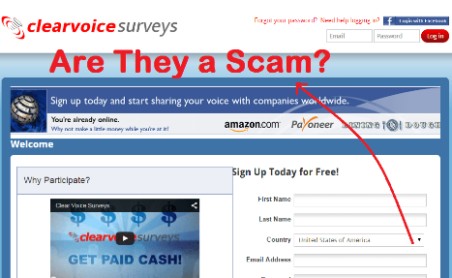

## 

## Figure 2.0.2 clear voice survey incentive



## Figure 2.0.3 clear voice survey ratings about a particular product

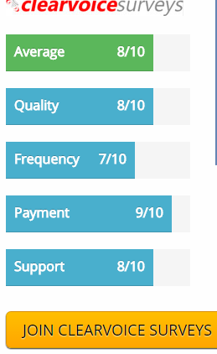

## Systems available globally

## 2.2.2.1 Google Forms

This a globally online survey tool management system, it is simply a questionnaire set up, a question is sent to the targeted audience and response show up in real time in a single sheet.

## Figure 2.2.1.1

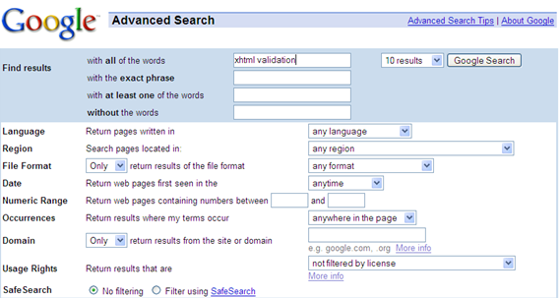

Figure 2.2.1.2

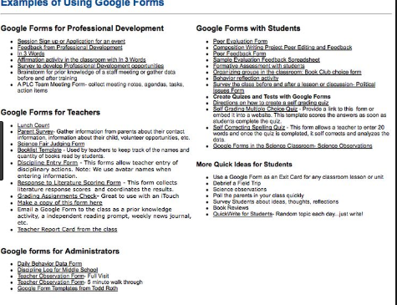

Figure 2.2.3

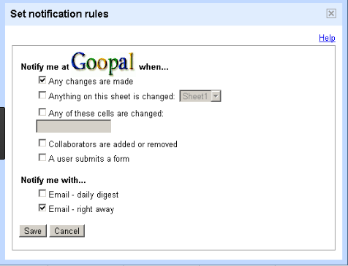

## 2.4 Proposed System

The proposed system will capitalize on the strengths of the existing systems and try to solve the challenges that are still not addressed by the systems in place. The researcher would want to incorporate various strengths and add some functionality to what exists and come up with a system with sufficient solution to the problems facing entrepreneurs and their customers. The proposed system will be computer based and this will make it easy for the entrepreneurs to carry out a survey without much hassle.

The system will include the pictures of the premises and location of the premises. These features will be used to come up with a system where customers can view the available product, see the products image, and order. The system will make sure that the entrepreneurs get direct feedback from the customer without any modification of what the customer thinks or opinion about a particular product. The system will also contribute greatly to the survey because it will generate reports analyze the customers feedback store the information a template like in the database.

Finally, the system will be modelled in such a way that it will be open to improvements, as the demands will dictate in the future. At present, it will be one of the up to date systems that will help investigator or start up organization to carry out survey from an entire range of people irrespective of their locations and whereabouts the clients will have an opportunity to recommend what they need from the organization.

## 2.5 conclusion

The proposed system will combine all the capabilities of some of the available systems and come up with one that incorporates them and improves on their weaknesses to come up with a completely rounded system that will not only solve the current problems, but also look at the future will optimism.

The security of the records kept will also be ensured by performing regular data backups to an offsite location or to a remote offline drive.

It will also allow the investigator to know the facts about the business they are involved in making it easy for them to make decisions based on the facts rather than the use of individual who may not provide some information to protect their contract.

### 

### Chapter 3

### 3.0 Research Methodology

### 3.1 Introduction

A project methodology is a model, which project managers employ for the design, planning, implementation and achievement of their project objectives. There are different project management methodologies to benefit different projects.

A software development methodology or system development methodology in software engineering is a framework that is used to structure, plan, and control the process of developing an information system.

### 3.2 System Development

### 3.2.1 Prototype model

Prototyping Model is a systems development method (SDM) in which a [prototype](http://searchcio-midmarket.techtarget.com/definition/prototype) (an early approximation of a final system or product) is built, tested, and then reworked as necessary until an acceptable prototype is finally achieved from which the complete system or product can now be developed.

The users provide feedback to the developers regarding the prototype: what is correct, what needs to be modified, what is missing, what is not needed, etc. Based on the feedback, the prototype is modified to incorporate some of the suggested changes that can be done easily, and then the users and the clients are again allowed to use the system.

This cycle repeats until, in the judgment of the prototypes and analyst. Based on the feedback, the initial requirements are modified to produce that final requirements specification, which is then used to develop the production of a quality system.

The researcher proposes to employ the prototype system development model. This is because the prototype allows the developer to work on the system as well as testing of it along the way until the user requirements are achieved.

The researcher chose this method because it allows users to take an active part in the development of the system; there is improved collaboration and communication between developers and users. Unlike waterfall method where a client is not very clear of what they exactly want from the software, this method accommodates the users in the development process and any changes that they need to be made to the system can still be made.

Unlike in the waterfall method where any changes made within the development process causes a lot of confusion, this method will not bring confusion because it accommodates user involvement in the development process.

This model will allow the users to start interacting with the system as soon as the developer starts the work of developing it. The users will be allowed to add their inputs through raising their concerns even as the work continues. This will make the users feel part of the development process and will therefore find it easy during implementation since they will have known how the system operates and this will reduce resistance in the implementation stage.

The prototype gives the user an actual feel of the system. At any stage, if the user is not satisfied with the prototype, it can be discarded and an entirely new system can be developed. Because of this, the researcher decided to use this method to allow the user get the feeling of the system and give room for an overhaul of the system whenever the users don’t feel satisfied with it.

The researcher settled on this method because the system to be developed is large and looks complicated. Nevertheless, prototype is known to be an attractive idea for complicated and large systems like this for which there is no manual process or existing system to help determine the requirements. Risks associated with the projects will also be reduced by prototyping.

The model follows the steps as shown in the figure below

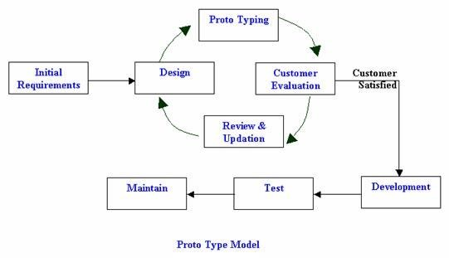

### Figure 3.2.1.1

### 3.2.2 Research Methodology

The researcher decided on a number of methods to collect the necessary information needed to make informed decisions about the system development. The methods used were; interviews, observation and the internet. These will help the researcher to come up with a solid resolution.

### 3.2.3 Data collection methods

### 3.2.3.1 Interviews

This is the technique where the researcher books a face-to-face appointment with the individuals in the research area to know how they interact with the systems in place.

This method was very helpful for this research since it gave the developer the opportunity to physically meet the system’s potential users and could easily read from their responses and from their expressions the agony that they are passing through in their day-to-day operations due to the absence of a reliable system.

The researcher used this method by preparing a set of questions that was asked to the business participants within the central business area in Nairobi with interviewing, it was concluded that talking to people is a good way to get information, to gather information that is not publicly available.

### 3.2.3.2 Observation

For the researcher to be certain about the responses given by the interviewed audience, the researcher resolved to use the observation method to ascertain the views of the interviewees. The researcher settled on this system because it lessens the workload since the researcher could check all the required data at a sitting as compared to the current systems where the data are scattered in different files kept in the shelves making it very difficult and time consuming.

The researcher has been part of the system by default because the researcher is an investigator and has faced all the worry when introducing a new product or commodity to the participant (customer)

### 3.3 System Development Tools

The system database will be developed using MySQL.

The abbreviation SQL stands for Structured Query Language that is an open-source relational database management system.

### 3.3.1 Database

MySQL is a central component of the LAMP open-source web application software stack (and other "AMP" stacks). LAMP is an acronym for "Linux, Apache, MySQL, [Perl](https://en.wikipedia.org/wiki/Perl)[/PHP/P](https://en.wikipedia.org/wiki/PHP)ython".

Applications that use the MySQL database include TYPO3, MODx, Joomla, WordPress, phpBB, MyBB, and Drupal. MySQL is also used in many high profile, large-scale [websites.](https://en.wikipedia.org/wiki/Website)

### 3.3.2 User Interface (UI)

Because the system is web-based, the User interface is developed using HTML (Hypertext Markup Language) which is the standard language for making web pages and web applications on the client side. It will also use Java, which is used as the server-side scripting language. The java codes will be embedded in HTML.

### 3.3.3 Hosting

The system will require testing before implementation even as the developer continues with the development process. This cannot be achieved without a server that is based in the computer. Because of these reasons, the researcher proposes the use of xampp as the local host server. XAMPP here stands for Cross-Platform (X), Apache (A), MariaDB (M), PHP (P) and Perl (P). It is free and open source cross-platform web server solution stack package developed by Apache Friends,consisting mainly of the Apache HTTP Server, MariaDBdatabase, and interpreters for scripts written in the PHP and Perl programming languages.

### 3.3.4 Text editor

The text editor used is Notepad++. It provides the platform which HTML and PHP codes can be written.

### 

### 3.4 Users of the System

### 3.4.1 System Administrator

The system admin will be allowed by the system to perform the following:

1. Add new users
2. View and edit existing users
3. Delete users
4. Monitor the system
5. Generate reports
6. Generate forms

### 3.4.2 Business owners

The business owners will have the following privileges:

1. Sign up
2. Sign in
3. View the remaining stock
4. Upload photos of new a product
5. Analyze the reports and forms

### 

### 3.4.3 Customers

Some of the customers/respondent privileges are:

1. Sign up
2. Sign in
3. View and comment about the vulnerability of a product or item

### 

### 3.5 System Design Model

System design is the process of defining the architecture, modules, interfaces, and data for a system to satisfy specified requirements.

This describes how different users will be interacting with the system. The steps involved are:

* Sign up
* Login
* Validation
* Loading of the home page

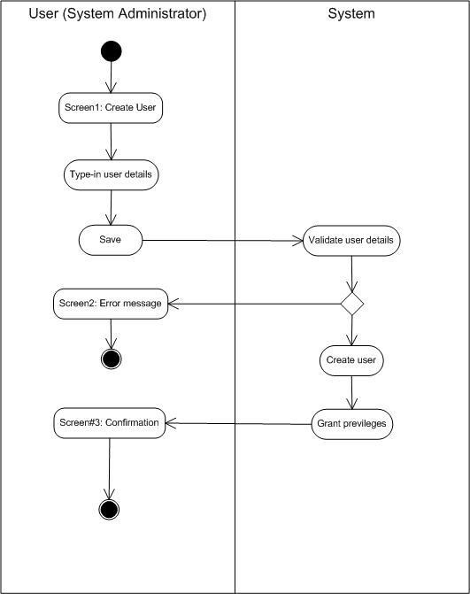

### Figure 3.5.1: Sign up and Login process

###### 

**Chapter 4.0 System Analysis and Design**

#### 4.1 Narrative

This system works and operate on a simplified network environment

The system administrator is responsible for setting up and maintaining the system or server, the system administrator is also responsible for installing, supporting, and maintaining servers or other computer systems, and planning for and responding to service outages and other problems. Other duties may include scripting or light programming, project management for systems-related projects.

The system administrator has limitless access to the system and can make any changes on the database without any restrictions pressed by the database administrators on privileges of the users. The organizations administrator cannot advance the privileges of the user unless they request for the advancements of these rights to the database administrator. After checking and making any necessary changes to the information on the database, the administrator must logout through the system.

#### 4.2 Use Case diagram



4.3 Flowchart



#### 4.3.1 Flowchart 2



#### 4.4 Entity Relationship Diagram



#### 4.5 Class diagram



##### CHAPTER 5: SYSTEM IMPLEMENTATION AND TESTING

##### 5.0 Introduction

The implementation of the system once rolled out is going to cover small business along the Nairobi central business district, testing of the system is done during the implementation process to ascertain that the system would achieve the basic design platform it is intended to perform. At the testing period some of the hardware’s

##### 5.1 system module

##### Web survey and report module

Used to offer both web survey and full-service web hosting. This was for the clients to produce reports on web pages irrespective of whether the data was collected on web.

##### Interviewing CATI Module

The module was used to manage telephone and enforce quotas. Computer assisted telephone interviewing worked with Interview Stations to provide a sophisticated CATI.

##### Online interviewing module

This was used to enable the survey to conduct any research to the interviewers anywhere they were as long as they internet connections in their devices

##### Survey recording module

The Survey System's Mobile Module offered superior features for conducting both simple and complex interviews on Windows-based Pocket PC hand held computers.

##### Online panel management module

The module was composed of the administrative portal and panelist portal that used both Web page and telephone surveys.

##### 5.2 Modules implementation

##### Web survey and report module

The module was used to offerand full service hosting, this enabled the clients to produce reports on the survey regardless of whether the data was from the web.

##### Online interviewing module

The surveyor conducted a survey from the targeted audience provided the targeted audience were connect to the internet.

##### 5.3 Information security

The information collected from any of the surveys will be stored in google cloud storage by providing a unified offering across the availability spectrum, from live data tapped by today’s most demanding applications. The database will also be used to encrypt any valuable information from any of the conducted surveys.

##### 5.4 Conclusion

As a process for integrating human considerations into the system engineering process, the developer has built on the strengths of existing systems engineering process model (prototype) to synthesis an incremental commitment model that help situate activities within a system’s life.

##### 

###### CHAPTER 6: CONCLUSIONS AND RECOMMENDATION

###### 6.0 INTRODUCTION

In this chapter, we report our broad conclusions related to each of the themes we introduced at the start of the documentation. These conclusions reflects detailed consideration.

###### 6.1 ACHIEVEMNETS

1. Satisfying system stakeholders e.g. users acquirers developers requirements
2. Incremental growth of system definition and stakeholders’ commitment
3. Concurrent system definition and development
4. Iterative system definition and development

###### 6.2 DIFFICULTIES

1. Suitable drivers for the microprocessor were not available.
2. WordPress libraries obtained from the internet were incompatible
3. Programming in a complexed web html language that we were not familiar.

###### 6.3 CONCLUSION

Human performance and human-system integration will never be most effective in system design unless all the stakeholders see it as integral part of the entire system engineering process, from initial exploration and concept evaluation. The developer concludes that the definition of user requirements should begin when the system is first being conceived, and those requirements should continue to provide important evaluation criteria right up to the time the system is placed in use.

###### 6.4 RECOMMENDATION AND FUTURE STUDY

The main objective of this project is the design an automated survey system that can analyze records store them and retrieve them when need.

However, the following challenges were encountered during the implementation: The database chosen to control the automated system posed to be a challenge as suitable driver for the microprocessor were not available. WordPress libraries obtained from the internet were incompatible with the local host machine. Programming in a new web html language that we were not familiar.

Any further work on the project could incorporate the following suggestions for improvement:

1. More security features can be incorporated to alert the system of any breach.
2. The webcam could be used to incorporate real time video survey alongside the captured images.

###### Reference

1. National Council for science and technology, 2010

2. Commission on Systematic interoperability, Ending the Document Game, 2005

3. Services, Centers for Medicare and Medicaid, 2008

4.SystemDesignModeling-Control&DynamicalSystems, (http://www.cds.caltech.edu/~murray/courses/cds101/fa04/caltech/am04_ch2-3oct04.pdf)

(Retrieved November 27th, 2017)

###### Appendices

###### Appendices A:

<div class="herocontainer section">

<div class="col-team">

<div class="content">

<Div>

<h2>Survey software for Organizations. </h2>

<p class="descr">Scale our tailored business solutions to solve any organizational challenge - no matter how large or

complex.</p>

</div>

<div>

<a class="btn btn-primary btn-green marb20 request-teams-pricing" href="/insights-platform/" title="EXPLORE OUR SOLUTIONS">EXPLORE OUR SOLUTIONS</a>

</div>

</div>

<div class="col-line"></div>

</div>

<div class="col-individual">

<div class="content">

<div>

<h2>Survey platform for Individuals.</h2>

<p class="descr">We empower individuals with world-class survey tools to make smarter decisions.</p>

</div>

<div>

<a data-plan="100"

data-acf-plan-id="LicensedSingle-standart-x27v3aj9nv321zlaemr4vz6ic3hu"

data-is-btn-descript="false"

class=" btn trial-signup btn-blue marb20 btn-blue marb20"

href="#">CREATE A SURVEY</a> </div>

</div>

</div>

</div>

###### Appendix B:

A sample of interview questions to the business managers

*What are some of the challenges you face when introducing new products to your customers?*

*How do you get to know a particular product is on high demand by your customers and how do you know the stock remaining in the stores?*

*How do you know a certain product is trending in the market?*

*How long do you stay with a product in your stores if the sales of that particular product is not convincing to the customers?*

*What are some of your suggestions to the challenges your face in your day-to-day activity?*

###### Appendix C:

###### Project Deliverables

|  |  |  |
| --- | --- | --- |
| **Activity** | **Start period** | **End period** |
| Initial investigation | 22/1/2017 | 26/1/2017 |
| Collection of data | 27/1/2017 | 31/3/2017 |
| Requirements definition | 1/4/2017 | 10/4/2017 |
| Dev. Of use cases | 14/4/2017 | 20/5/2017 |
| System design | 22/5/2017 | 1/7/2017 |
| User interface development. | 03/7/2017 | 20/8/2017 |
| Coding & Testing | 23/8/2017 | 3/9/2017 |
| Implementation and  maintenance | 7/10/2017 |  |

###### BUDGET

|  |  |  |
| --- | --- | --- |
| **Product** | **Description** | **Proposed Amount** |
| Computer | Desktop/ Laptop | 20,000ksh |
| Genuine windows | XP/2007/2008/2010 | 10,000ksh |
| Processor | At least Core(TM) i3 400 CPU@ 2.40GHZ | 3000ksh |
| RAM | 2GB OR 4GB | 500ksh |
| Network | Internet connectivity | 2500ksh |
| Printer | Hp LaserJet 2055dn | 25,000ksh |
| **Grand Total** |  | **61000ksh** |

|  |  |  |  |  |  |  |  |  |  |  |  |  |  |  |  |  |  |  |  |  |  |  |  |  |  |  |  |
| --- | --- | --- | --- | --- | --- | --- | --- | --- | --- | --- | --- | --- | --- | --- | --- | --- | --- | --- | --- | --- | --- | --- | --- | --- | --- | --- | --- |
| WE | ACTIVITY | 1 | 2 | 3 | 4 | 5 | 6 | 7 | 8 | 9 | 10 | 11 | 12 | 13 | 14 | 15 | 16 | 17 | 18 | 19 | 20 | 21 | 22 | 23 | 24 | 2 |  |
| 1 | Project Proposal |  |  |  |  |  |  |  |  |  |  |  |  |  |  |  |  |  |  |  |  |  |  |  |  |  |  |
| 2 | Literature Review |  |  |  |  |  |  |  |  |  |  |  |  |  |  |  |  |  |  |  |  |  |  |  |  |  |  |
| 3 | Methodology |  |  |  |  |  |  |  |  |  |  |  |  |  |  |  |  |  |  |  |  |  |  |  |  |  |  |
| 4 | System Development and Design |  |  |  |  |  |  |  |  |  |  |  |  |  |  |  |  |  |  |  |  |  |  |  |  |  |  |
| 5 | Coding |  |  |  |  |  |  |  |  |  |  |  |  |  |  |  |  |  |  |  |  |  |  |  |  |  |  |
| 6 | Implementation |  |  |  |  |  |  |  |  |  |  |  |  |  |  |  |  |  |  |  |  |  |  |  |  |  |  |
| 7 | Project Presentation |  |  |  |  |  |  |  |  |  |  |  |  |  |  |  |  |  |  |  |  |  |  |  |  |  |  |
| 8 | Maintenance |  |  |  |  |  |  |  |  |  |  |  |  |  |  |  |  |  |  |  |  |  |  |  |  |  |  |

###### Gantt chart